**3. lexical Analyzer**

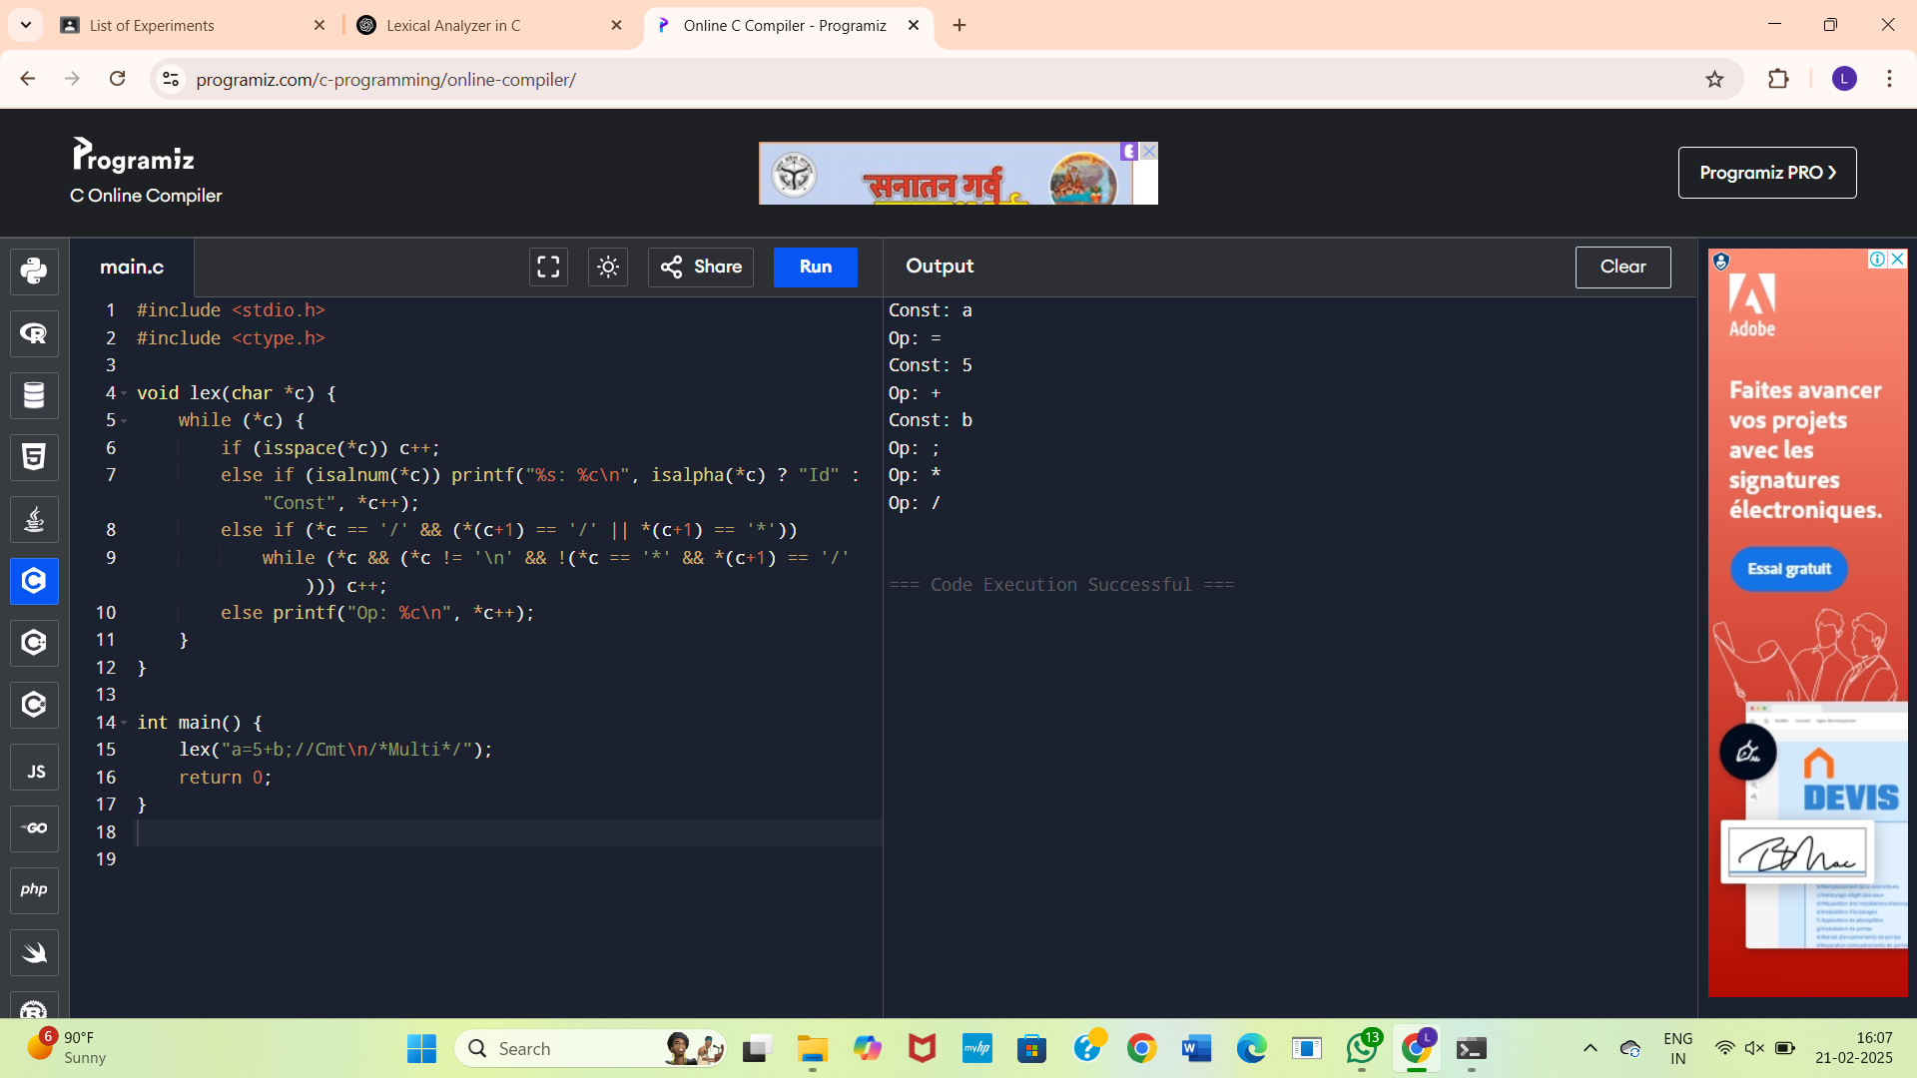

**4. Operator Validator Lexical Analyzer**

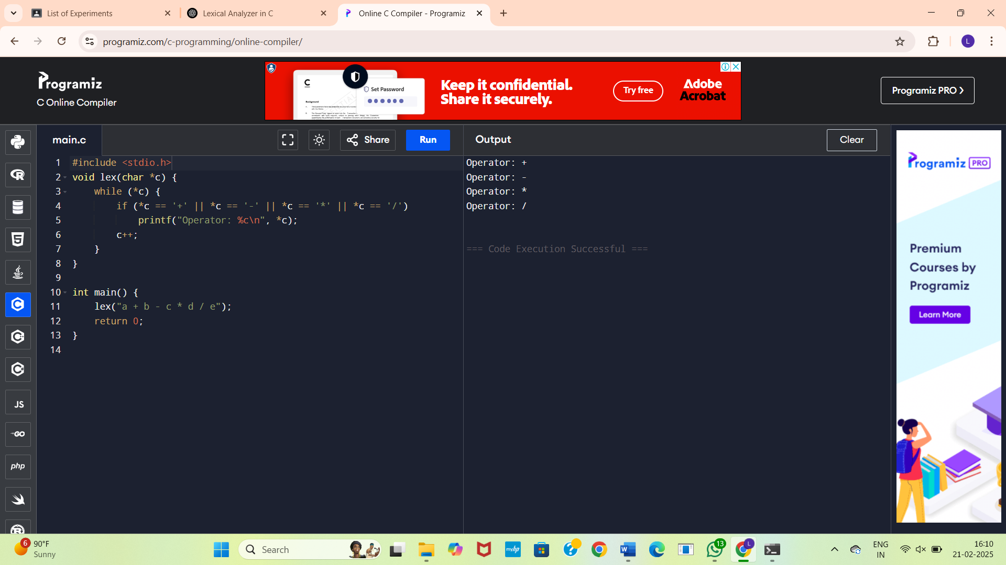

**5.Whitespace and Newline Counter**

